Title: | Web Quest How Computers Work
Area: | Technology & Enterprise

Unit Code:

Lesson No.
Title: | Web Quest Computer basics

Notes:
Teacher: | Mr Peter Faulks

Contact:

Timeline:

Due Date
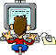

WEB Quest
Items in blue offer some information and notes and items underlined are links to help you get answers you should find more links to help you answer questions
Questions are numbered or may be highlighted = answer where you see this Answer: (Most of the answers are in this document)

It is important to check connection before you turn it on. The following images are connections for common peripherals that connect to your computer.

  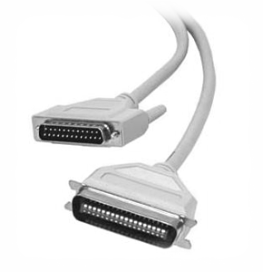 | Parallel Printer
  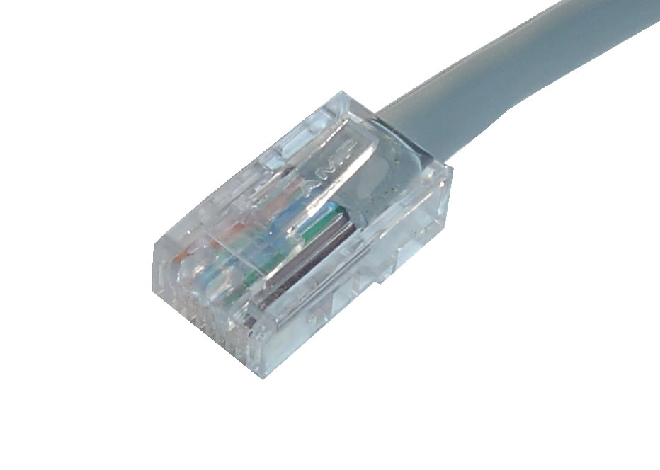 | Network
  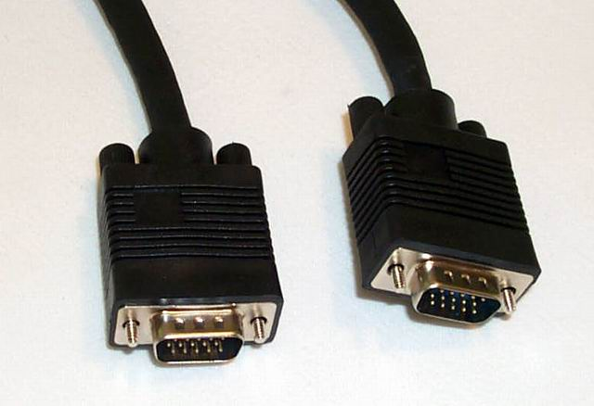 | Monitor
  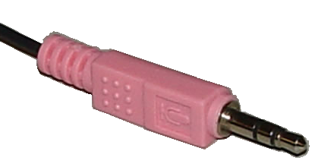 | Microphone
  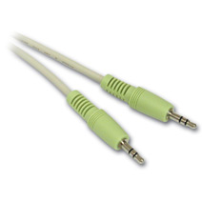 | Speakers
  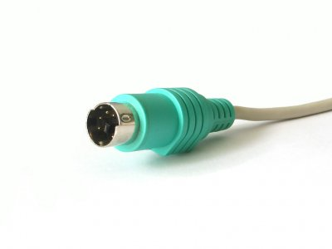 | Mouse Serial  (also USB)
  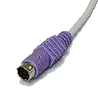 | Keyboard serial  (also USB)
  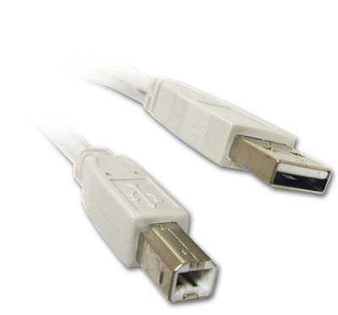 | USB Printer

If a computer does not look safely connected or some cables appear damaged, you should not turn on the computer. You should contact the appropriate person such as a workplace supervisor, IT technical expert, or your manager to have the machine looked at first.

- Activity 1- Peripheral device connection
Match the connection to its device associated device

 | ⬧ | ⬧ | 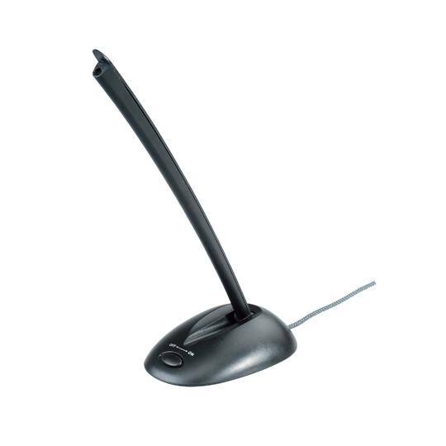
 | ⬧ | ⬧ | 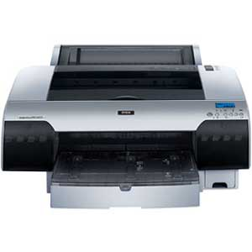
 | ⬧ | ⬧ | 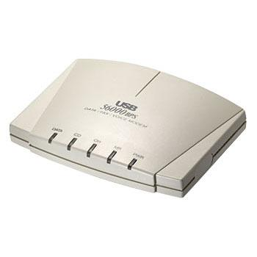
 | ⬧ | ⬧ | 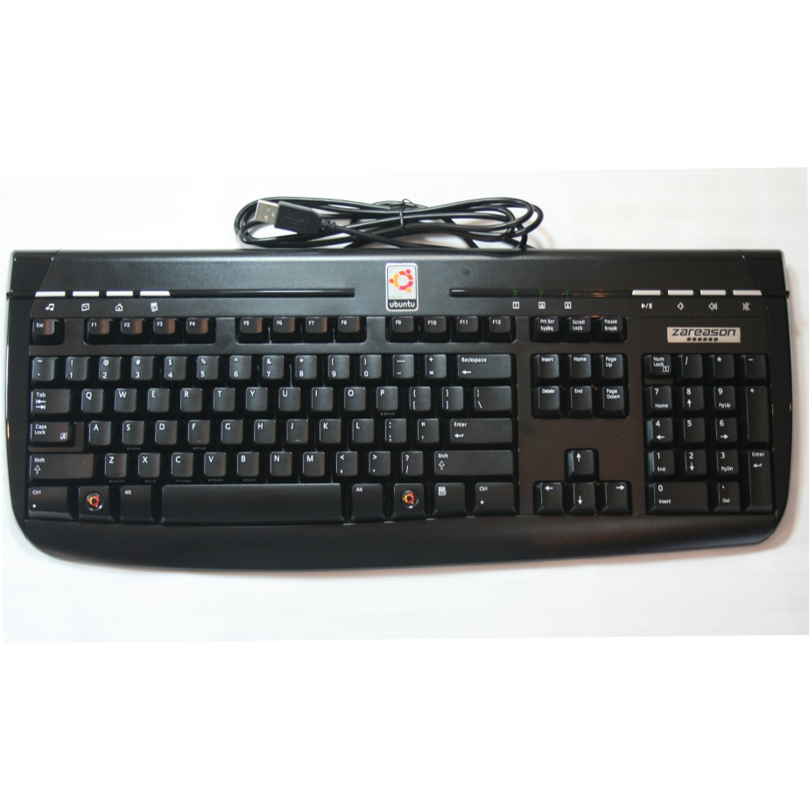
 | ⬧ | ⬧ | 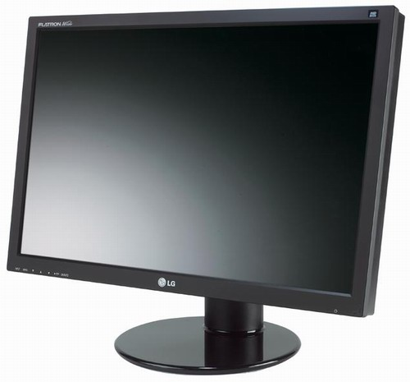
 | ⬧ | ⬧ | 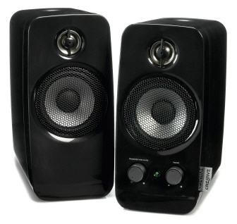

2. What should you do if connections appear damaged?
Answer:

3. Observe the computer lab you are working in. How are you required to turn the computer on? Do you use the power button on the tower or the power point?
Answer:

4. What is your personal responsibility with regards to safety in your own work area? For example, if you see a pencil in the walkway between student desks, is it your responsibility to pick it up to ensure nobody steps and trips in it?
Answer:

Access basic system information
To access a computer after turning it on, you usually have to log on using a username and password. Logon screens look similar to the ones below.

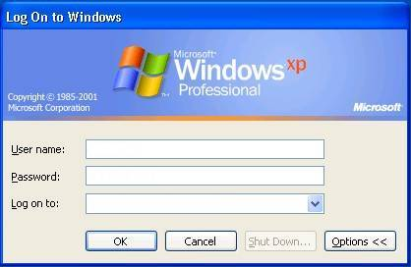

Activity 2 – Logging onto a Computer
5. Find out the process of accessing a computer at your school. Ask your teacher about any rules and regulations about using the school computers? Summarise your findings below.
Answer:

Identify basic functions and features using system information
The following diagram represents how a computer works

INPUT  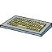   |  | PROCESSING  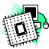 |  | OUTPUT  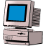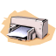  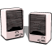
STORAGE



Firstly data is entered into the computer via an input device such as a mouse, microphone or keyboard. This data goes in the ‘brains’ (CPU or Central Processing Unit) of the computer for processing. The information can then be stored on a storage device such as a disk, CD, or USB drive and/or be output to an output device such as a monitor, printer or speakers.

Activity 3 – Functions and Features of Computers
6. Describe what each of the following parts of a computer does and specify whether it is an INPUT, OUTPUT, PROCESSING, or STORAGE device.
Device | Description | Type of Device  (circle correct answer)
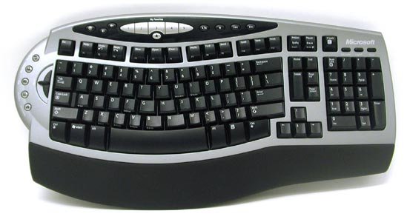 |  | INPUT  OUTPUT PROCESSING STORAGE
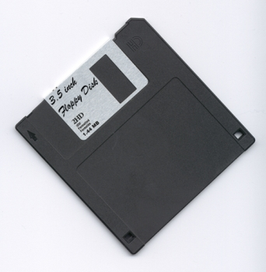 |  | INPUT  OUTPUT PROCESSING STORAGE

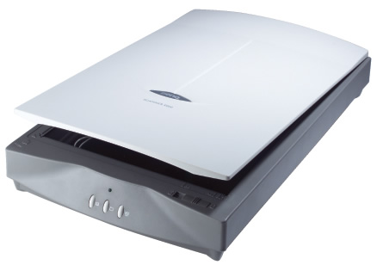 |  | INPUT  OUTPUT PROCESSING STORAGE
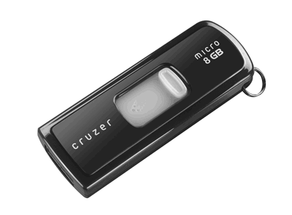 |  | INPUT  OUTPUT PROCESSING STORAGE
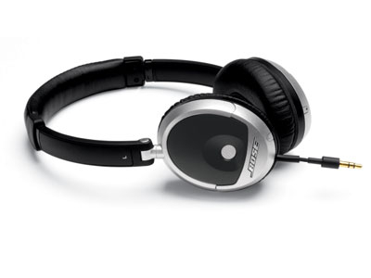 |  | INPUT  OUTPUT PROCESSING STORAGE

Describe the following Storage devices.
7. ZIP Disk
Answer:

8. USB Drive
Answer:

9. CD/DVD
Answer:

10. HDD
Answer:

11. How do you format a disk?
Answer:

12. What is the purpose of formatting a disk?
Answer:

Hardware VS Software
The physical parts of a computer (i.e. the parts you can touch) are referred to as hardware. A piece of hardware can’t run by itself. For example, a printer won’t print unless it gets instructions to do so. The ‘thing’ that makes a computer ‘do something’ is called software. When you use your mouse to select the print function on your computer, it is likely you are using a piece of software.

Software comes in two flavours. Operating System Software and Application Software.

Operating System (OS) Software
Operating System Software is a piece of software that controls the hardware and other application software on your machine. It allocates resources such as space to store files, determines which tasks are completed first and in which order, and communicates with hardware. Basically, it controls the entire computer system.

Application Software
Application Software is software that has a specific purpose. You use application software to complete tasks. For example, Microsoft Word is used for word processing, Microsoft Excel for spreadsheets, and Internet Explorer is used for surfing the internet. Application softwares are often called ‘programs’.

System Information
The term system information refers to the ‘techy’ information about your computer. It usually refers to things like, the type of operating system on your computer, how fast it works, how much space it’s got...etc. You may find that you have to know this information when speaking to a technical support person. The images over the next few pages show

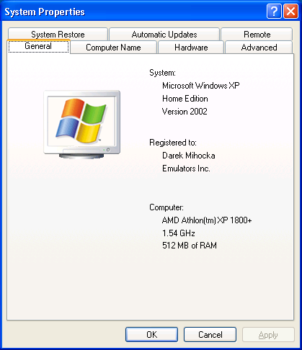
This is the Operating System
This is the processor

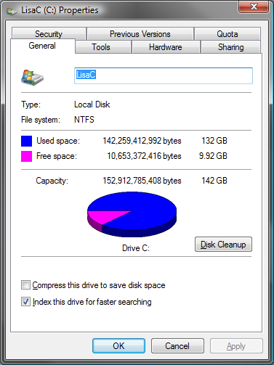
This is how much space is on your computer

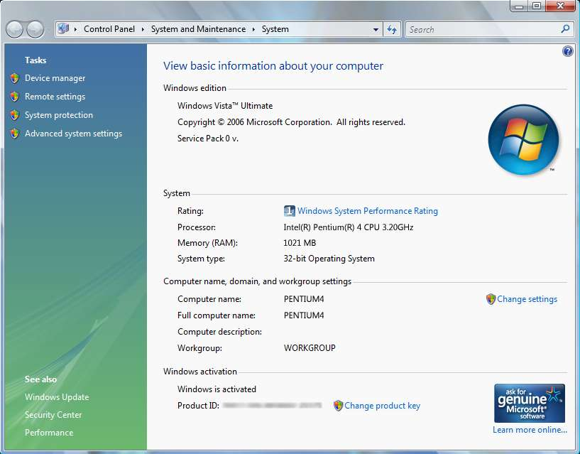

Activity 4 – System Information
Find out how to access system information on your computer and answer the following questions.

13. How did you find the System Information?
Answer:

14. How much RAM has your computer got?
Answer:

15. What is the name of the Operating System?
Answer:

16. What is the name of the processor?
Answer:

17. How much space is on your Hard Drive?
Answer:

18. How did find out how much space is on your hard drive
Answer:

Help
Most computers have a help system to help with the overall function of the computer. Helps is usually also available with each individual program too. You will make use of the help system in the next activity, so find out from your teacher how to access and use the help system on your computer.

Desktop
The “desktop” of your computer is like your desk. It is an area you work on and can keep commonly used programs and files. The desktop of your computer typically looks like this

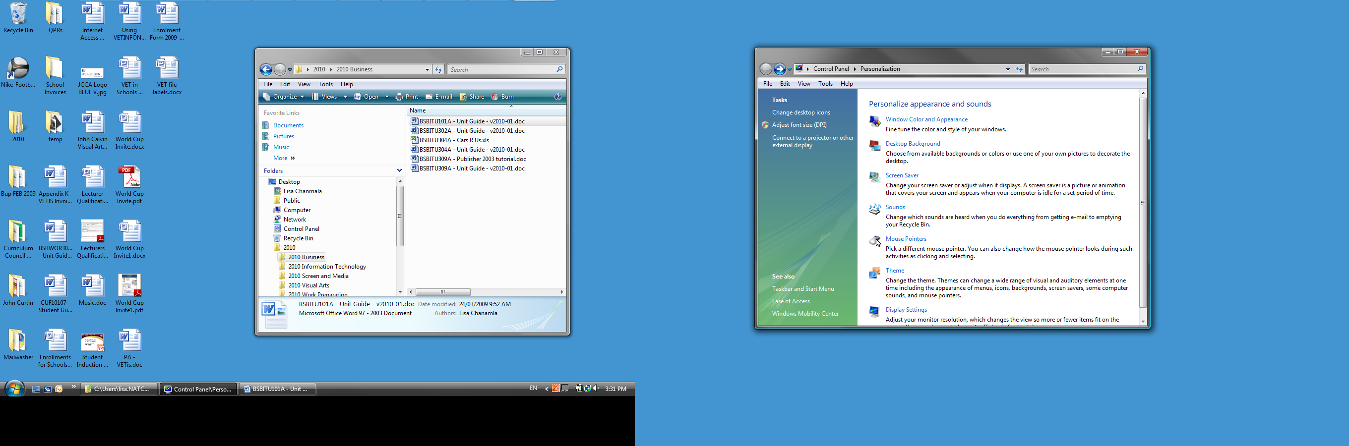
These are desktop icons; they represent programs and files you use all the time
This is the start button. You use this to start programs and access files
This area is generally referred to as the desktop
This is a window. It represents a task you are currently working on.

This is the task bar. It displays any tasks that you are currently working on

Navigate and manipulate desktop environment

One of the most basic skills of using a computer is to navigate around windows.

Activity 5 – The desktop environment
Using the Help and Support Centre on your computer, find out how to complete the following tasks:

19. How do you resize windows?
Answer:

20. How do you create desktop icons?
Answer:

21. How do you change the desktop background?
Answer:

22. Does your school allow you to set the desktop background to your own pictures? Why or why not – consult your teacher.
Answer:

23. What do the following buttons on a window do?
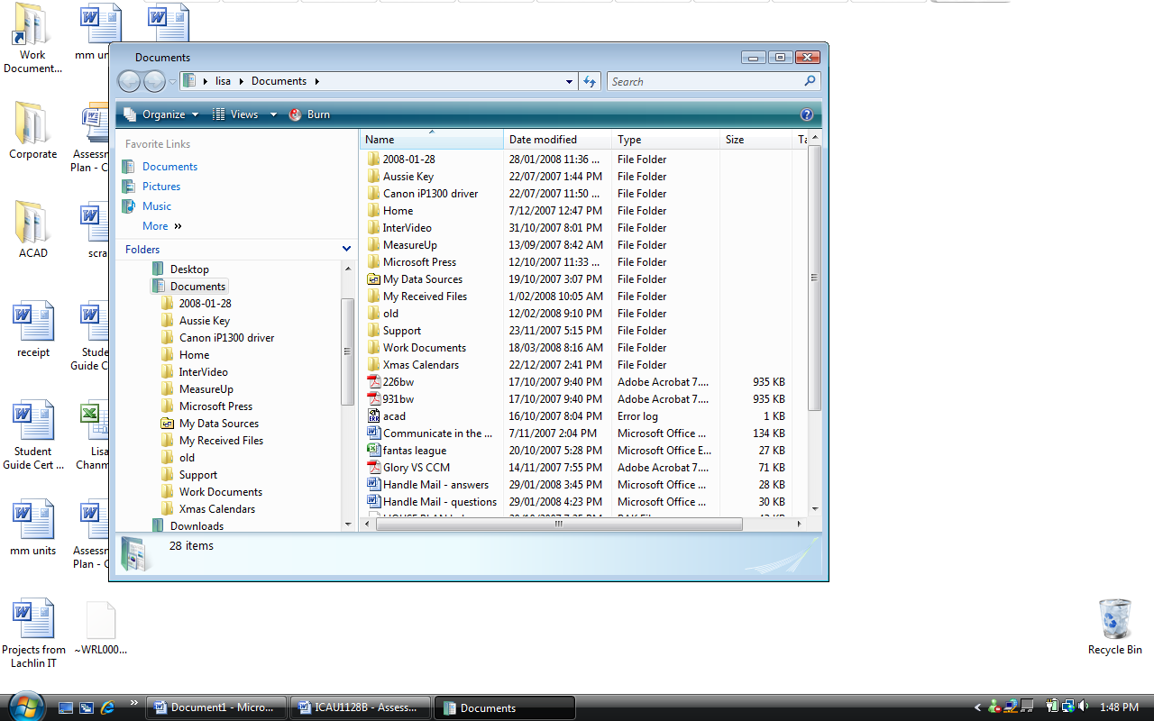
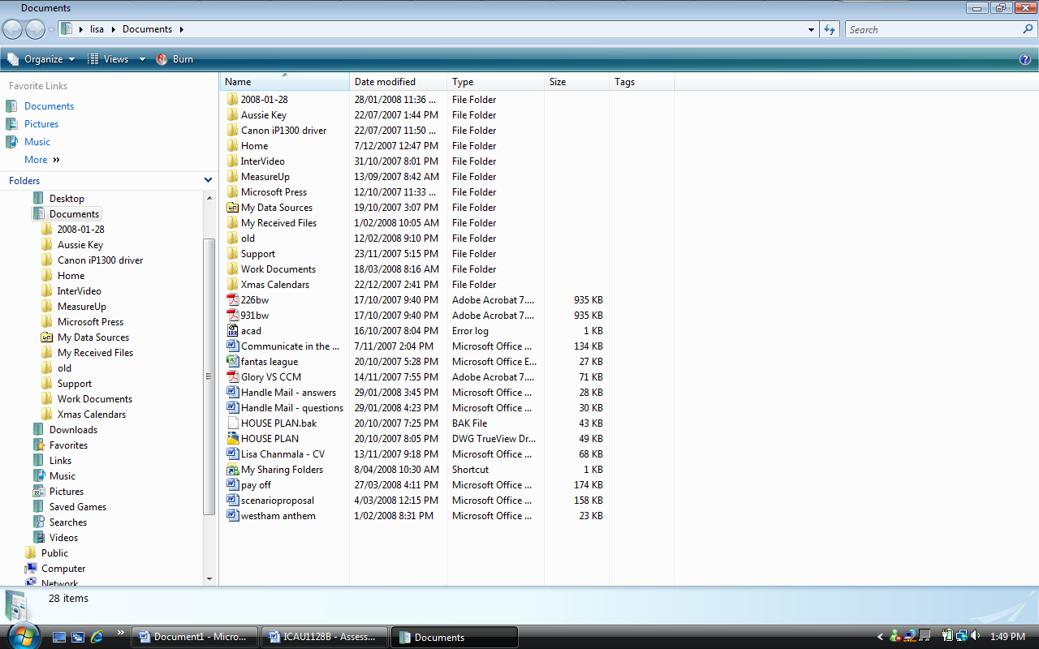

24. List different ways to select multiple files or folders
Answer:

25. Describe the term screen resolution and how do you change it?
Answer:

26. How do you access a program that has a shortcut on the desktop?
Answer:

Organise files using basic directory and folder structures
Files – are documents like flyers, newsletters, databases...etc that you work on

Folder – are an area which you store your files – think of it as a fling cabinet

Activity 6 – Files and Folders
Using the Help and Support centre find out how to complete the following tasks and then attempt the activity for practise.

27. How do you create folders?
Answer:

28. How do you rename folders?
Answer:

29. How do you find out the properties of a folder?
Answer:

30. How do you delete a folder?
Answer:

31. How do you restore a folder from the recycle bin?
Answer:

32.What are some different ways you can move/copy files and folders?
Answer:

33. What is the difference between moving a file or folder as opposed to copying a file or folder?
Answer:

34. How do you use the Search function in Windows?
Answer:

35.How access the most recently used files on a computer?
Answer:

36. True or False? You can access folder and files by using “Windows Explorer” or “My Computer”
Answer:

Activity 7 – Create files and folders
37. Step 1 – Create the following files by opening a document add a title then save as into your folder using Microsoft Word
Carrot.doc | February.doc | Orange.doc
May.doc | Red.doc | June.doc
January.doc | Tuesday.doc | Monday.doc
Lettuce.doc | Blue.doc | March.doc
Green.doc | April.doc | Apple.doc

38. Step 2 – Create the following folders on your desktop
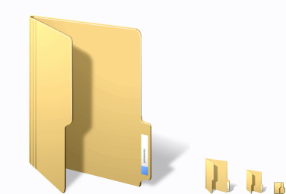Vegetables | Fruit | Months | Days | Colours
39. Step 3 – Move the files created in step 1 into the appropriate folders. Experiment with the drag and drop and cut and paste techniques.

40. Step 4 – Look at the properties for each folder. How many files are in each folder?
Folder | Number of Files
Vegetables
Fruit
Months
Days
Colours

41. Step 5 – Search for the file February.doc. Where was it found?
Answer:

Naming Conventions
When working in business, you often need to adhere to naming conventions for files and folders. Naming conventions are a set of rules that you need to follow when naming files and folders. For example, if you were typing letters for clients, you may be required to include the customer number in the file name.

The reason why naming conventions are used is to ensure everyone in the company names and orders files and folders in the same way, especially for new employees. It also makes searching for files and folder easier. For example, if you have some idea about what a file or folder is called, it will make it easier to find using the search function.

Activity 8 – Producing a document within organisational requirements
42. You have been asked to type a letter for your supervisor for a particular client. You are also to check for any spelling mistakes and fix them. Sign of the letter to say it is from you. Your letter must be stored on the desktop inside a folder called “Clients”. The letter must be named with the clients first and last initial in capital letters followed by a dash and then the year. (Your teacher may discuss other naming conventions with you if required)

Client: Wayne Rooney
Address: 379 Manchester Utd Road
London ENG 69040
Message: Mr. Rooney, this leter is to advize you that your goods have arived. You are more than welcome to come and pick them up at our office durng busines hours or we can courier then out to u at a cost of 10 pounds.

Activity 10 – Keyboard functions
43. Describe what the following keys do or how you use them.
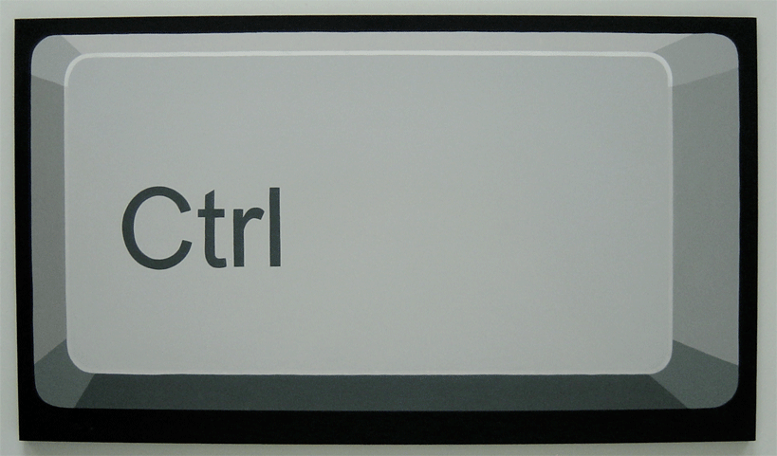
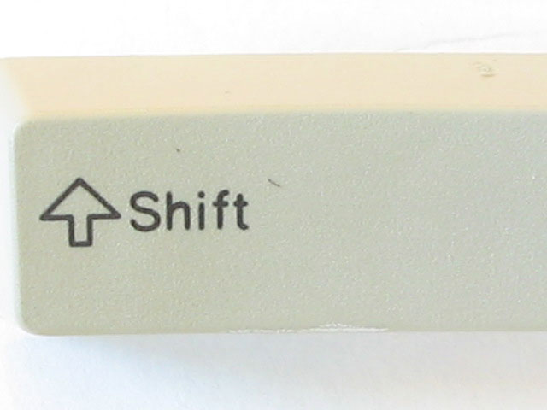
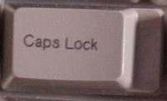

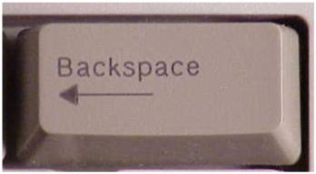
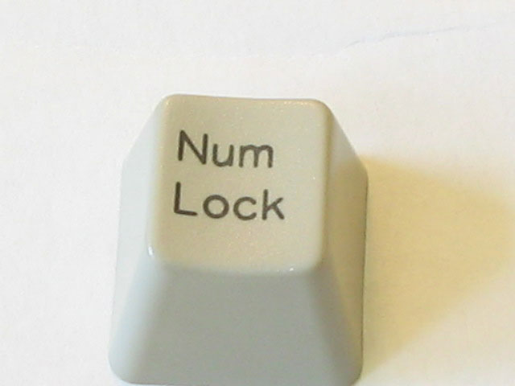

Print information

Activity 11 – Printing
Using the Help and Support Centre print out the instructions on how to complete the following tasks. Write a summary in your own words on how to complete each task in MS Word. Save these documents to your USB drive. Name the files as per below. Ensure your name, date, and the title “ICAU1128B - Activity 11” are somewhere on the document. Print a copy of each summary for your portfolio.

- How to Install a Printer (Filename: ICAU1128B – Activity 11 – Install a Printer - <your name>)
- How manage print jobs (Filename: ICAU1128B – Activity 11 – Manage Print Jobs - <your name>)
- How to change default printer (File name: ICAU1128B – Activity 11 – Default Printer - <your name>)

Shut down computer

Activity 12 – Shutting down a computer
Place a number in the circle next to each step to indicate the order of steps you would take to shut down a computer
Click the Start Button, and go to the Shut down button
Close down all programs/applications
Save all work
Safely remove your USB drive along with any other removable devices

44. Why must you remove devices before shutting down a computer?

Task Computer basics
Computers vary from the very small to the very large. They can differ in the speed at which they process data, memory size, physical size and price. Some examples include handheld computers, laptops / notebooks, desktop computers, mainframes and supercomputers. The rapid development of technology means that even these categories of computers are changing.
All computers have some basic principles in common. They are all electronic devices that:
• take in input from a user in the form of data
• process data
• store data and
• make data available for output as information.

Data is the raw fact which we enter into a computer for processing. An example might be the runs made by a particular batsman in each cricket match that he plays.
Information is the meaningful knowledge we obtain from processed data. For example the batting scores in each cricket match (data) can be processed to inform us what that player’s batting average is.
Scroll your mouse over the diagram below for a simple plan of the basic components of a computer.

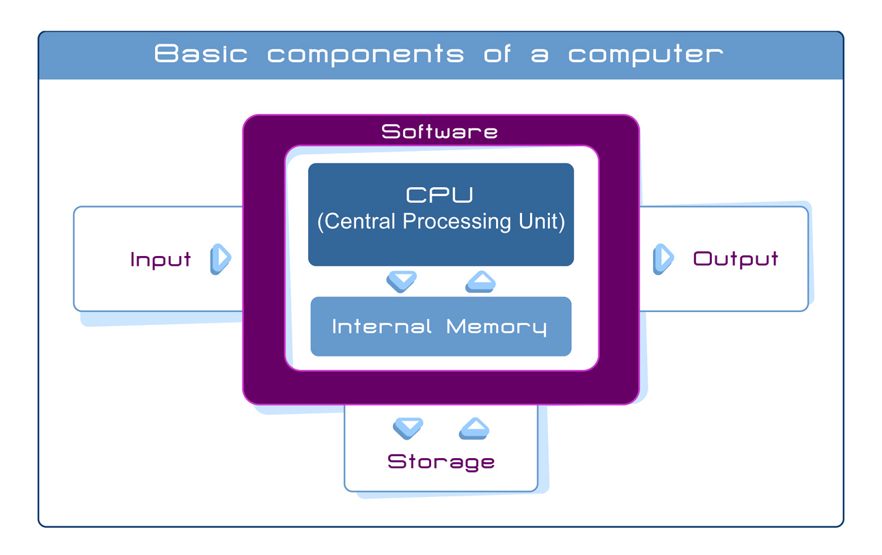

Computer components
What type computer equipment are you working on? It is probably a desktop computer or maybe a laptop. Your computer consists of hardware and software. Hardware is the physical component of your computer. It includes the parts of a computer we can touch, such as the systems unit containing the Central Processing Unit (or CPU), the keyboard, mouse, printer, chips, disks, etc.
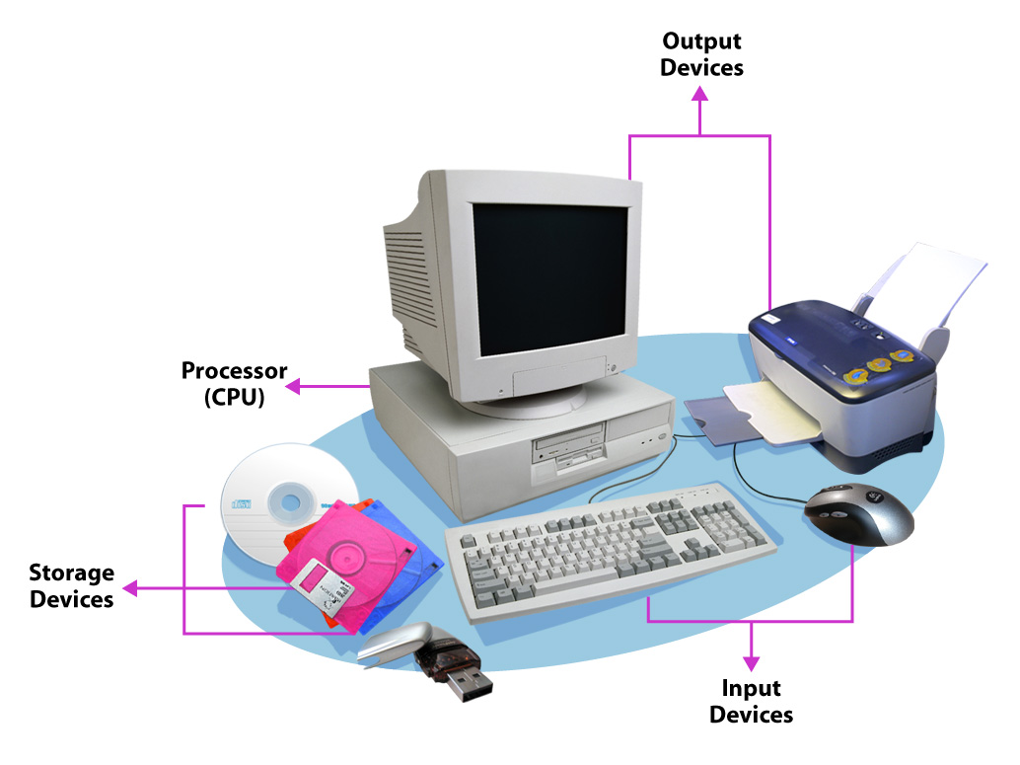
Software is the computer programs that makes the hardware work. Microsoft Word is an example of software. We will look at software more closely later in the week.
Hardware peripherals are those items
connected to the computer and controlled
by its CPU. Peripherals can be internal
such as sound cards and CDRoms or
they can be external. External
peripherals such as the monitor
and scanner, are connected via
cables or through wireless
connections such as some
keyboards and mice.

A typical desktop computer may consist of the following components:
Input Devices | The keyboard and mouse are used to input data into the computer. A scanner and digital camera can also be used for this purpose.
Processing | The system unit, or tower, contains the Central Processing Unit (CPU) which processes the data to produce information.
Output Devices | The monitor displays information and the printer allows you to produce a hard copy of that information. Both of these are output devices.
Storage Devices | The processed data can be stored on the hard disk inside the tower or can be stored on portable devices such as floppy disks, CDRoms or DVDs or USB thumb drives.

Understanding the desktop
Think about the desk that you work and study at. When you do your study, does it contain everything that you need? Can you move documents and folders around as you need them or even pile them up? Your computer desktop is the same.
The desktop is the screen (output device) on which the icons (small pictures of objects) are seen when you start up your computer.
The way your desktop screen looks is determined by the operating system your computer uses. Most operating systems now use a graphical user interface (GUI). This means that the programs, files and options are presented on the screen as icons, menus and dialogue boxes. These icons allow you to launch computer programs easily and quickly. You do not need to type precise commands, simply use a mouse to select the icon and click.

Apple® Macintosh® desktop
If you are using an Apple® Macintosh® Operating System, your desktop may look something like this:
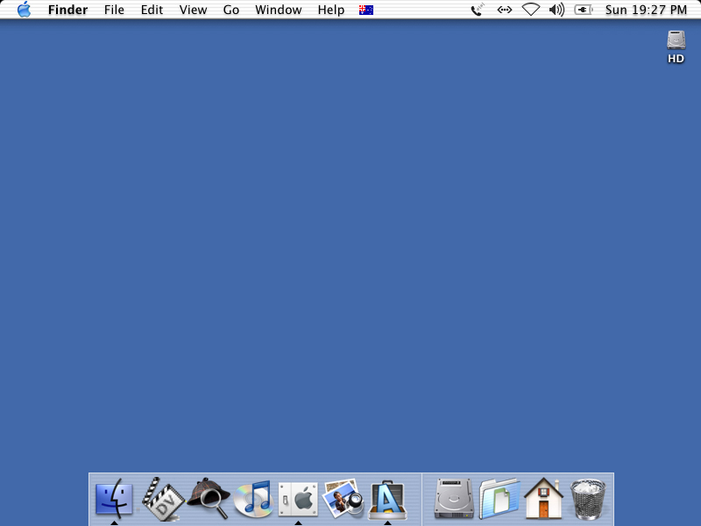

Linux®-based desktop
If you are using a Linux®-based Operating System, your desktop may look something like this Linspire® desktop.
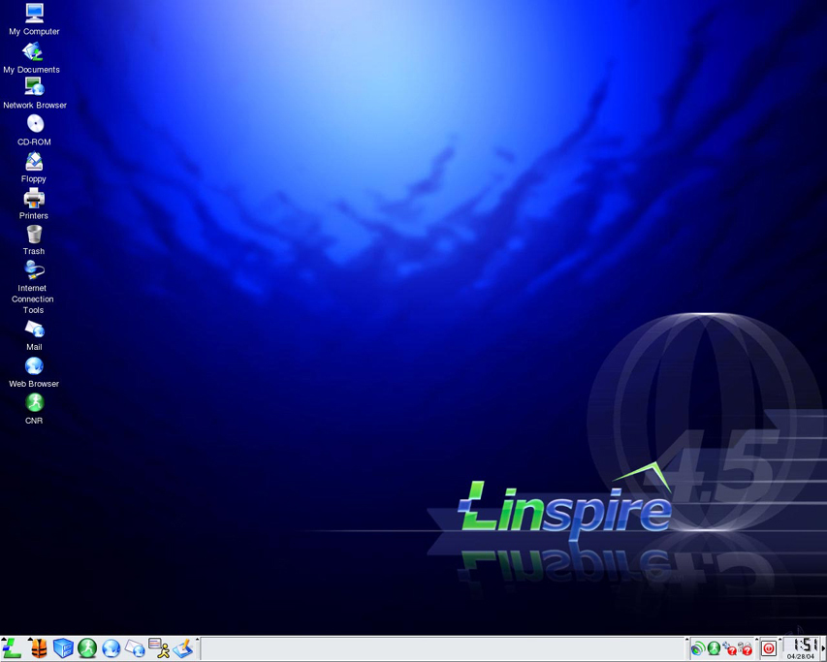

Microsoft® Windows® desktop
If you are using the Microsoft® Windows® Operating System, your desktop will look something like this:
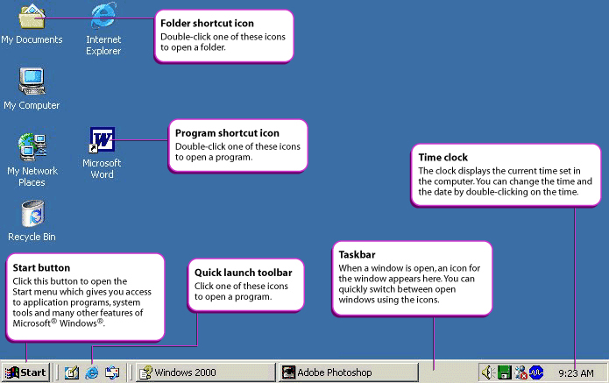
On the above diagram have a careful look at the icons described there.

Looking at windows
In a graphical user interface like Microsoft® Windows®, when you open a program, a document or a web browser, it appears on your desktop inside a window.
The following illustration shows a typical Microsoft® Windows® window. Most GUI operating systems use minimise, maximise and close buttons, however, they may not share the same toolbars or title bars.
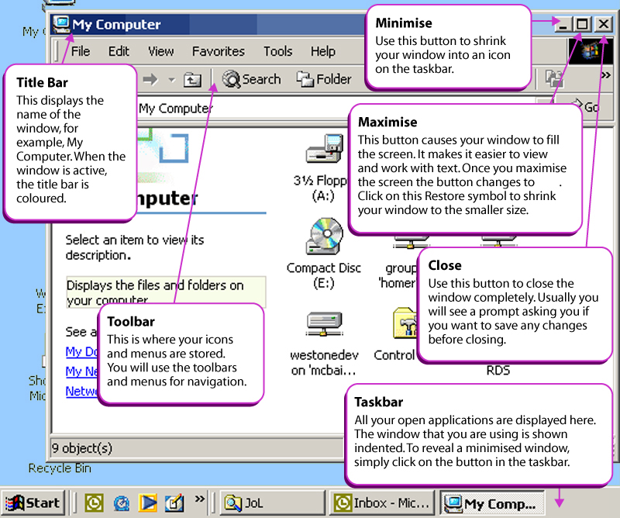

If you open an actual application, in this case Microsoft® Word, the information is opened in a window with a variety of features and toolbars.

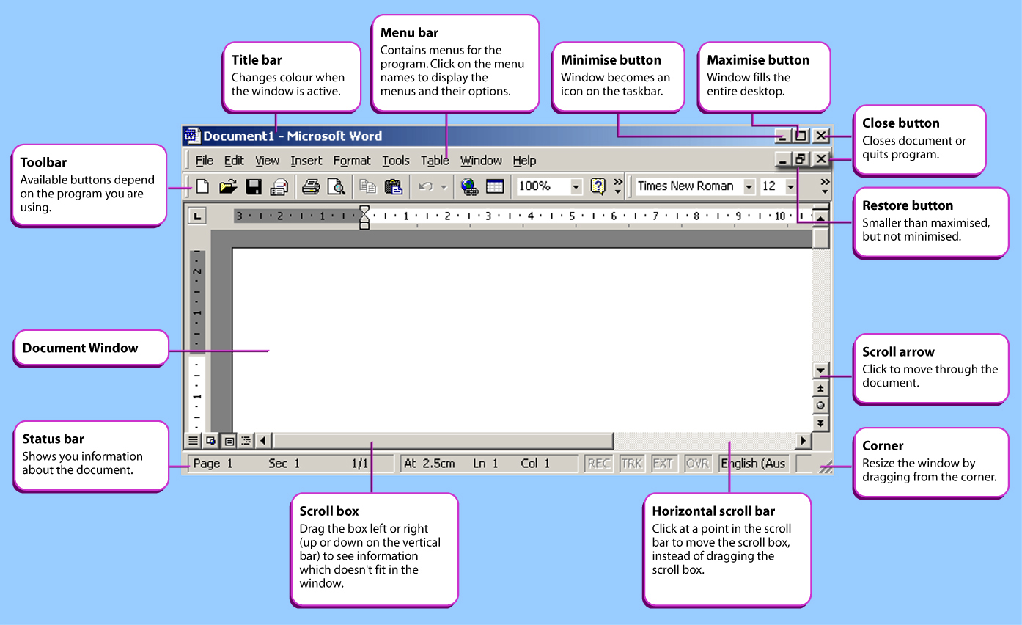

Dialogue boxes
Dialogue boxes appear when some information is needed from the user. Dialogue boxes pop up and ask you to make a selection, or confirm an action, or sometimes they appear as a warning.
The following illustration shows a typical Microsoft® Word dialogue box for saving your work.
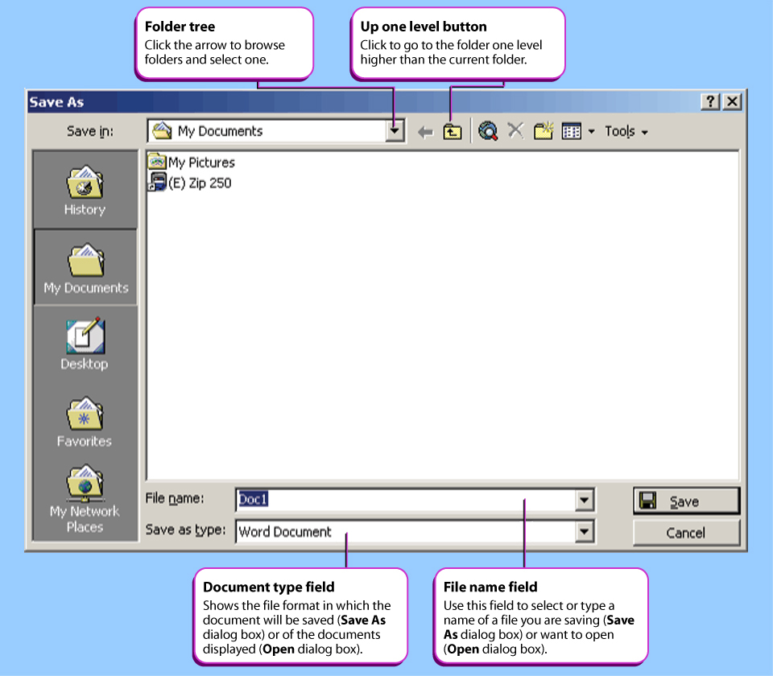

Some dialogue boxes are used to change system settings. These are often subdivided into tabbed categories, like a real-life folder or card file. Click on a tab to change from one section to another.
The following illustration shows the Microsoft® Windows® Date/Time Properties dialogue box:
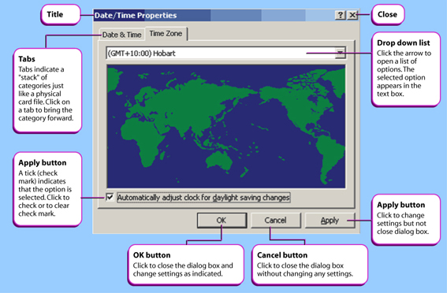
45. Identify the computer parts

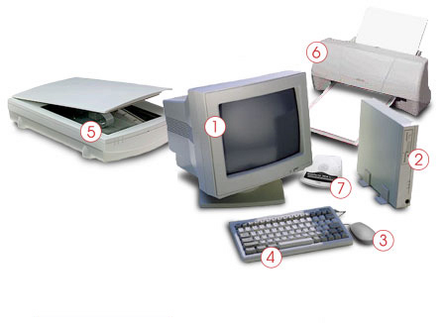
1 Answers here
2
3
4
5
6
7
8

Basic computer functions
All computers, from the smallest hand held computer to the largest supercomputer, perform the same basic functions with digital information. Those functions are:
- Input—typing characters at a keyboard, moving the mouse around the screen or speaking to a computer
- Output—displaying characters or pictures on the screen, printing a research paper, or sending an e-mail message
- Process—calculating the square root of a number, sorting a list of names, or producing a three-dimensional image
- Store—saving your research paper or resume, keeping track of your credit card purchases, or archiving digital pictures of your relatives
- Retrieve—recalling a list of addresses or business contacts
Computers perform these five fundamental functions in different ways and at different speeds, but they all use digital data to perform the tasks.

What makes up a Computer?
Two separate things make up a computer: hardware and software. They go hand in hand. You cannot have one without the other.
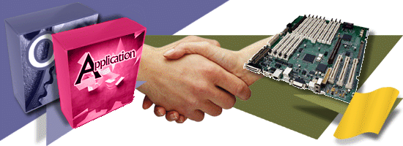

Hardware is the physical part of a computer, anything you can touch and anything you can see. Yet, hardware is nothing unless it has software to control it. In a way, hardware is like a car without a driver or a saw without a carpenter; you need both to make something happen.
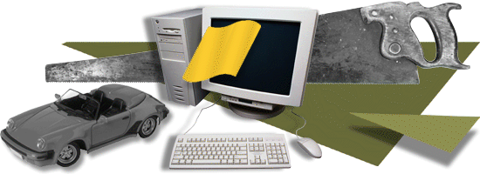

Software is the brains of the computer. It tells the hardware what to do. You must have software to make a computer go. In fact, software determines your computer's personality.

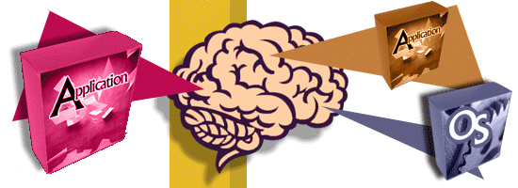

Computer software is nothing more than instructions that tell the hardware what to do or how to act. Computer software is more important than computer hardware. The software tells the hardware what to do.

Although computer software comes on disks (CDs or floppy disks), the disks aren't the software. Software is stored on disks just as music is stored on cassettes and CDs.

The main computer box is the console, though it might also be called the system unit. It's a box that contains your computer's guts plus various buttons, lights, and holes into which you plug the rest of the computer system.
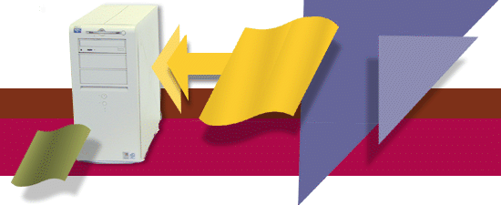

The monitor is the TV-set-like thing on which the computer displays information.
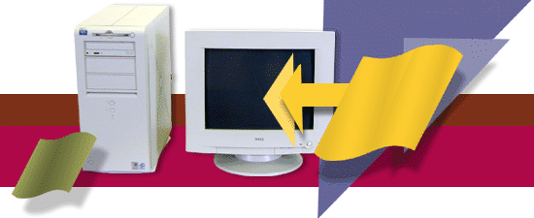

The keyboard is the thing you type on.
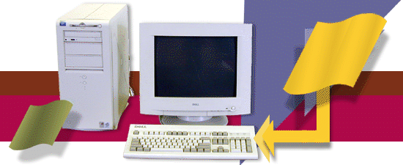

The computer mouse is a helpful device that lets you work with graphical objects that the computer displays on the monitor's screen.
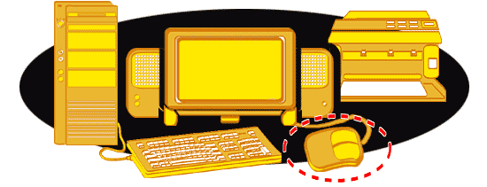
Mouse
The mouse has various functions. It is used to select and open things. Most mouses have at least two buttons and a scrolling wheel.

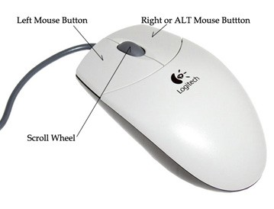

More information about learning how to use a mouse:
http://webinstituteforteachers.org/2000/curriculum/homeroommodules/compBasics/CBMouse.htm

46. Go to the following tutorial and practise using the mouse. Describe what the following terms mean. http://www.mouseprogram.com/

Left click
Answer:

Double click
Answer:

Right click
Answer:

Drag
Answer:

Right-drag
Answer:

Double right click
Answer:

Scrolling
Answer:
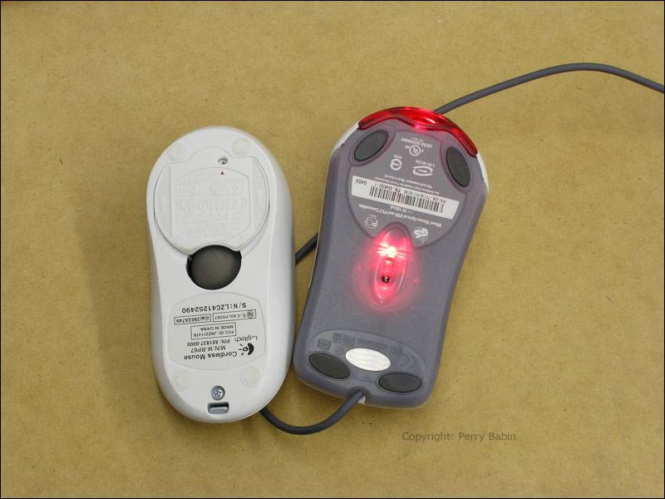

Most PCs can emit sounds through a set of stereo speakers, either external ones you set up or speakers that are built into the console or the monitor.

46. Which plug usually connects the speakers 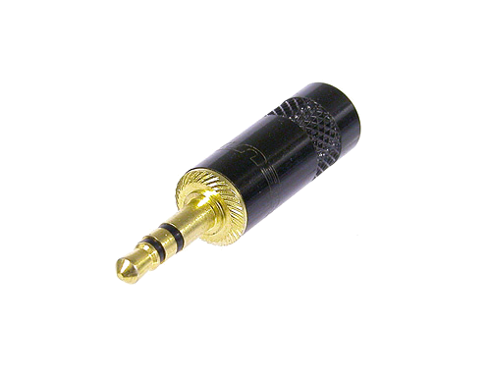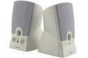
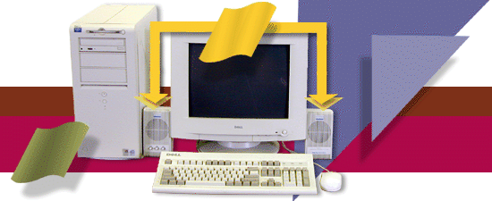

The printer is where you get the computer's output: the printed stuff, also called hard copy. If the printer isn't present, it's probably a network printer sitting in some other room.
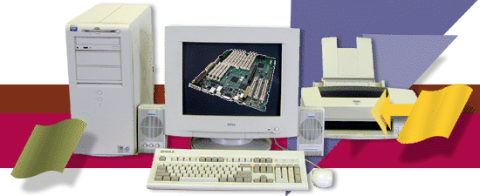

If your computer has a modem, it's usually located inside the console. You can see it from the back. Some modems do live outside the console, but that's less common today than it was ten years ago.

A scanner is used to scan in graphic images and printed material, transforming them into graphics you can manipulate, e-mail, or does a number of interesting things with inside the computer.

Oooh! It's Color-Coded! (Show the back of a computer)
The new trend in computer hardware is to color-code the connectors on a PC's rump. So in addition to the intergalactic icon for speaker or sound-out, you now have the color green. That's the good news. The bad news is that each computer manufacturer tends to use its own color-coding for everything. Fortunately, the connectors still look different and are still tagged with the international symbol or text. The table lists the common colors used by most makes

Start the Computer
Checking peripheral device connection for correct position and switch on power at both the power point and computer
Source: http://www.hsc.csu.edu.au/info_tech/compulsory/use/3460/connectors.htm

Plugs Ports and Connectors

I/O ports
To accommodate different types of input and output hardware, a computer has several places where the input/output, as well as storage-hardware is connected to the processing unit. These places, connected to the motherboard, are called I/O (Input/Output) ports.
Three types of I/O ports are available: serial, parallel and USB. Serial ports have been around for decades. Parallel ports are a more recent invention and are much faster than serial ports. USB ports are only a few years old, and will likely replace both serial and parallel ports completely over the next several years.

Serial and parallel ports
Considered to be one of the most basic external connections to a computer, the serial port has been an integral part of most computers for more than 20 years. Although many of the newer systems have done away with the serial port completely in favour of USB connections, most modems still use the serial port, as do some printers, PDAs and digital cameras. Few computers have more than two serial ports.
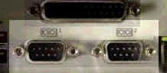
Data is sent between the computer and the attached hardware one bit at a time with a serial port. When a parallel port is used, the entire bit pattern for a single character is sent at the same time. The advantage to using a parallel port is that it is faster than a serial port, as it sends several bits simultaneously. However, the I/O and storage hardware must be physically close to the computer. While serial ports do not provide as high a transmission speed, the peripherals can be further away. Serial ports are used to help send data over telephone and other communication lines.
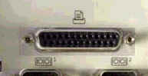
While USB is becoming increasingly popular, the parallel port is still in use to connect a range of peripherals.

When a PC sends data to a printer or other device using a parallel port, it sends eight bits of data (one byte) at a time. These eight bits are transmitted parallel to (beside) each other, as opposed to the same eight bits being transmitted serially (all in a single row) through a serial port.

USB ports
All computers today come with one or more Universal Serial Bus connectors. These USB connectors let you attach everything from mice to printers to your computer quickly and easily. Connecting a USB device to a computer is simple; find the USB port on your machine and plug the USB connector into it.
The Universal Serial Bus allows you to connect up to 127 devices to a computer. Each device can consume up to a maximum of 6 megabits per second of bandwidth.
Just about every peripheral made now comes in a USB version. These include printers, scanners, mice, joysticks, flight yokes, digital cameras, webcams, scientific data acquisition devices, modems, speakers, telephones, video phones, storage devices and network connections.
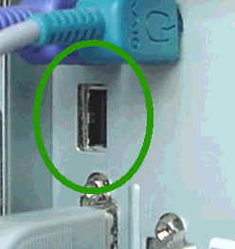
If it is a new device, the operating system auto-detects it and asks for the driver disk. If the device has already been installed, the computer activates it and starts talking to it. USB devices can be connected and disconnected at any time.

Many USB devices come with their own built-in cable, and the cable has an "A" connection on it. If not, then the device has a socket on it that accepts a USB "B" connector.
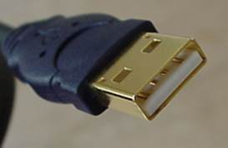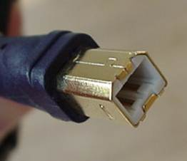
The USB standard uses ‘A’ and ‘B’ connectors to avoid confusion. ‘A’ connectors head ‘upstream’ toward the computer, while ‘B’ connectors head ‘downstream’ and connect to individual devices.

Most computers that you buy today come with one or two USB sockets. With so many USB devices on the market today, you easily run out of sockets very quickly. The easy solution to the problem is to buy an inexpensive USB hub which can support up to 127 devices.
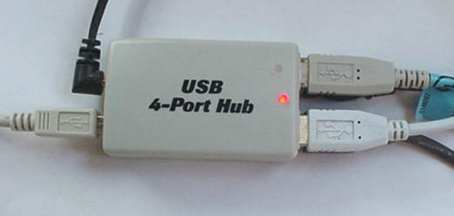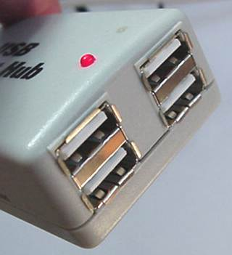
A hub typically has 4 new ports, but may have many more. You plug the hub into your computer, and then plug your devices (or other hubs) into the hub. By chaining hubs together, you can build up the number of available USB ports on a single computer.
NAME:_________________ DATE:___________ TIME TAKEN: _____ min: ____sec

Item | Connector details – what kind? | Use?  (audio, video, data storage, power, connectivity) | Works on Mac? (checked by partner) | Works on PC?  (checked by partner) | Manual  Installation page no’s
Power plug

Monitor

Keyboard

Mouse

Printer

Headphones

Microphone

External floppy drive
Digital video camera
Network cable

Thumb-drive

Scanner

Web-cam

47. Computer Connection - Disconnect all cables then re –connect –
A Time Frame may be issued

Ask teacher to start the session.
Observed by teacher? |  | Done without interruption to class?
Acceptable time-frame? |  | Ergonomic layout of equipment?
All peripherals worked? |  | Cables organised safely/neatly?
Mouse correct side for user? |  | Disconnected and re-packed neatly?
No power turned on until devices connected?

Peter Faulks 2009

